Programming On The Internet

Assignment 1: Duck Hunter

Graham Mace

MIT2 / Group B
Specification ::

In 1984, Nintendo released a game for their popular Nintendo Entertainment System (NES) called ‘Duck Hunt’. The game used an input device known as the ‘NES Zapper’ or ‘Light Gun’ that was pointed at the television and allowing the player to ‘shoot’ ducks that appeared on the screen. These ducks had to be shot within a certain amount of time with only three shots available. The game featured three modes coupled with a high-scores table that was saved to the cartridge, along with full-screen animation and simple yet effective sound effects.

This assignment is to create a clone of the ‘Duck Hunt’ game and deploy it over the Internet so that it can be played by almost any computer. The game itself must be capable of all or some of the following features:

- A menu system for controlling the game’s start up, shutdown and pausing.
- Smooth animated images for the duck on-screen.
- Multiple ducks appearing on-screen at the same time
- Background image on which the ducks move around.
- Sound effects that respond to user’s actions.
- A high score table that is saved to disk.
- Multiple game modes with different amount of ducks and shots.
- Time limit per round.
- Multiple game options such as sound on/off.
- Loading screen on game start up.
- Different scores per duck.
- A game scaling structure using ‘levels’.
- Easy to play and navigate.
- Intuitive interface with accurate descriptions.
- Scalable graphics for different display resolutions.
- Different power-ups that change the game’s state when collected.

Almost all of these features could be incorporated into the game, but of course this is dependant upon the amount of time available. Using the original ‘Duck Hunt’ as a reference, the basics of the game will be created first, which can then be expanded upon to produce an enhanced Java port of the Nintendo classic.
Design :: Code

As the game is to be distributed over the Internet, the code must be able to run on multiple operating systems across a wide variety of hardware. Therefore, Sun’s programming language Java has been picked as the platform of choice. Java runs what is known as a ‘virtual machine’, or Java Runtime Environment (JRE), that acts as a translator between the compiled Java byte code and the operating system on which the JVM is running.

There is a similar version of the JVM software by Microsoft called .NET, which compiles code into what is known as the ‘Microsoft Intermediate Language’ or MSIL and runs on ‘Common Language Runtime’. The C# language, which is part of the .NET framework, has very similar in syntax to Java. However, the .NET framework has not been ported to other operating systems such as Linux or the Apple Mac and as such these platforms cannot run any .NET-based applications. This means that distribution of the game written for .NET will not work on an OS that does not have a fully-featured version of the .NET framework. However, both feature an object-oriented approach to programming and both are extremely powerful when it comes to writing any size of program.

As Java supports an object-oriented way of doing things, the game can be split down into smaller, more manageable chunks, known as ‘classes’. By starting at the simplest level and building up, this allows the game to be tested at each and every stage until an efficient and bug-free piece of software is produced. These individual classes can then be grouped together into specialist packages that deal with the various aspects of the software, which are then interlinked to produce a fully-functional game.

Through doing some research from some books and some tutorials found on the Internet, it seems one possible way to lay out the structure of these classes is as follows:

- Core – This package will contain the class that actually runs the main game loop, calculates some of the logic, displays the window and paints all the graphics to the screen. Along with this main class, there will also be a couple of other classes that manage the player properties and the player scores.
- Graphics – Responsible for managing sprites, animation and frames, the graphics package provides classes for what the user actually sees on screen. Other classes that load images and modify image transforms and dimensions will also be here.
- Sound – No game would be complete without some sort of audio representation of what is happening on screen – this package will provide the functionality for loading and playing individual sounds.
- UI – The classes contained within this package are the various windows that are presented to the player. This includes the game’s splash screen, options window, high scores table and main menu.
- Utility – The utility package will contain generic classes that provide functionality used by other classes for when the game is running, such as thread management and file operations.
- Configuration – All classes in this package provide a framework for the various game modes that the software can run, as well as the various configurable options in the game.

One of the bigger questions is whether the game should run full-screen or in a window. Having the game run full-screen allows us to harness the capabilities of the video card, at the downside of not being able to interact with any other windows surrounding where the game is on-screen. The game could be deployed as a Java applet which can then be embedded in a web-page, but this requires that the user’s web-browser be open for the duration in which the game is running. Another, more viable approach is to use the Java Archive format, also known as JAR.

By using a JAR file, all the sounds and images that the game needs can be compressed into a single file, which the user can then download from a website and run locally in the VM installed on their machine. This also allows high-scores to be saved on the user’s machine.

Design :: Graphics

The graphics for the game were obtained from various websites around the Internet, as well as from the Microsoft Office Online clipart collection.

- Background: The background image for the game came from the Office clipart collection online and was downsized and saved in the PNG file format for use within the game.

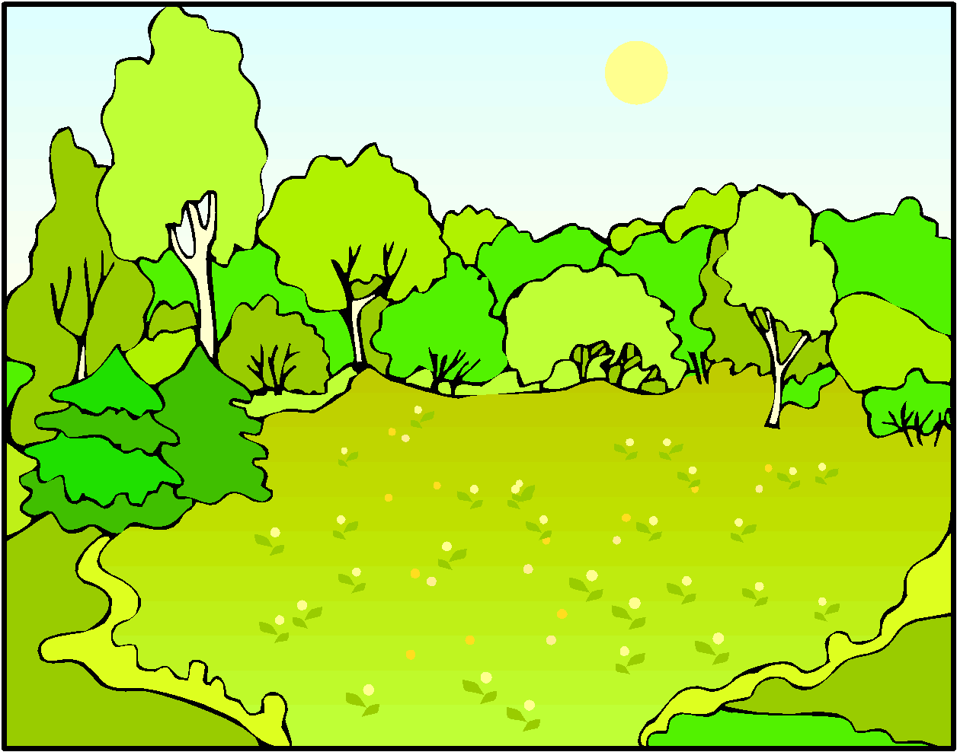

- Ducks: The individual frames used to render the duck on-screen were obtained from three separate animated GIF files that were contained on a web page. Each file contained between 20 and 25 frames, which then had to be extracted from the GIF file and resized accordingly. The original GIF file did not have any transparency on the frames causing the ducks to appear in a sold white box. This was quickly resolved by filling the background with a random colour, assigning that colour to transparency and then saving as a PNG file.

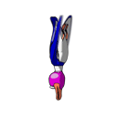

- Clouds: Again, taken from the Office clipart collection, the cloud images were simply black outlines with no fill. By using the airbrush tool in Adobe ImageReady the middle area of the cloud was filled with a shade of blue, then the background was made transparent and saved to a PNG.



- Bullet decal: Taken from a website that supplies clipart for use in office presentations, the bullet decals in the game were saved from the webpage and then converted to PNG files in a similar way to the frames for the duck.



- Blood decal: Obtained from yet another clip art website, the blood decals were scaled down, made transparent and saved from their native JPEG format into the PNG file format.



- Interface icons: The icons used on-screen to represent the duck were downloaded from the Office clipart collection, made transparent and coloured black for ‘live’ ducks and red for ‘dead’ ducks. The bullet icon was downloaded from an Internet website and not modified at all, except for being converted to PNG format.

- Status boxes: Created in Adobe PhotoShop, the text notifications that appear in the middle of the screen throughout the course of the game (such as ‘Paused’ or ‘Fly Away) were formed by having white text on a black background in a small box. Of course, text like this could be drawn natively in the game using the ‘drawString’ method, but this way does not provide an accurate way of positioning the text on the screen. Additionally, if the user does not have a particular font on their system the messages may not appear properly. By using an image file for this particular part of the game, this ensures that the text can be centered properly in the middle of the screen and is easily readable.





- Loading screen: Displayed when a game mode has been chosen, the loading screen features an image of a shotgun. This was obtained once again from the Office clipart collection, scaled down, made transparent and saved into the PNG format.



Design :: Sound

Locating sound for the game was a more difficult task than finding graphics for the game as each and every possible sound effect had to be listened to and checked.

- Ambience: The ambient sound for the game was added to loop as background noise and was taken from an MPQ media library for World of Warcraft. A tool called WinMPQ was used to extract the file, which was then loaded into Adobe Audition for checking, then re-saved to a format Java can read.

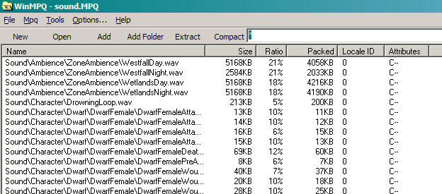

- Duck: The ‘quacking’ sound for the ducks was obtained from a sound sample website, which was then checked in Adobe Audition and then added to the game. The ‘dead’ sounds were taken from a Game Cache File (GCF) used by Valve Software’s Source engine.

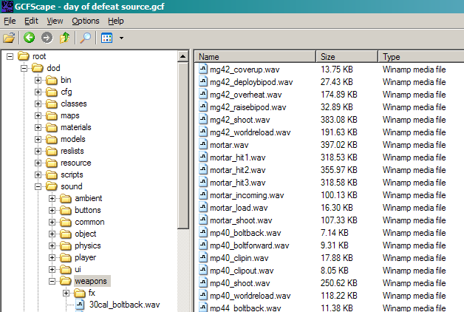

- Gun: The gun ‘shot’ sample was downloaded from the Internet, along with the ‘reload’ and ‘ricochet’ sound effects. The ‘reload’ sample had to be trimmed from an existing sample to achieve the sound effect required. The final ‘click’ sample - which plays when the player runs out of ammo – was taken from the same Source GCF file as the ‘dead’ duck sounds.
Testing ::

The testing for the game was carried out by various people with differing levels of technical knowledge. Doing this allowed the programmer to see how a particular person navigates and plays the game in order to see what potential problems still remain with the software. This also gave the tester a chance to suggest ideas for the game’s expansion and development. Of course, not all these ideas could be implemented within the time scale given, but it gave a chance to iron out any issues or cheating.

Toward the final stages of the game’s development there were a few teething problems that could not be resolved. One of these issues concerned the amount of memory available to the Java Virtual Machine. It seems whenever there are more than a certain amount of Ducks on-screen at any one time, the JVM crashes with an ‘OutOfMemoryError’ exception. However, this can easily be resolved by adding the command-line switches ‘-Xms64m’ and ‘-Xmx256m’, respectively increasing the stack size and heap size for the JVM. As a safeguard against this error, a flag was introduced into the code that attempts to prevent this error from occurring. Of course, this will only come into effect when large amounts of ducks are created at any one time.

Another issue that occurred during testing was with using threads to run some parts of the game. There is a problem whereby if the user starts a game, then quits to the main menu and starts another game, the second instance of the game is slower than the first. This appears to be something to do with the first instance of the game thread not closing properly. This is partly due to the fact that the programmer’s knowledge of Java threads is not very extensive. As such, a ‘tried and tested’ approach was taken by using a few lines of code from tutorials found on the Internet.

One problem that affected game play quite drastically was the amount of decals on the screen at any one time – this included the ‘blood’ and ‘ricochet’ images that are painted to the screen when a duck is hit or missed. When a large amount of these images are drawn, the frame rate of the game drops considerably. A quick fix for this problem was to introduce a constant variable that specified a maximum limit on the amount of decals at any one time. If this limit is exceeded, then the first decal in the list is removed, giving the illusion that the decals are ‘following’ where the player is shooting. An option was then added to the game settings that allowed the player to turn off this limiter.

During the course of the game’s development, a few minor problems ensued that were difficult to resolve. One of these bugs was affectionately known as ‘spazz-duck’, whereby the sprite image of the duck would get stuck at the edge of the screen and be unable to move. To solve this problem, an invisible bounding box was implemented to prevent the duck from going within 5 pixels of the edge of the screen. If the duck goes within this box, its direction is inverted until it exits this box and resumes its usual movement.

One other issue concerning the game’s performance was with when the game was launched – all the resources for the game had to be read from disk as they were needed. To combat this problem, a pre-loader class was introduced to load files into the respective caches before the main game is started. This presented a new problem – knowing what had to be loaded. This matter was quickly resolves by using a simple text file that lists all the resources used by the game. Upon starting the game, this file is read line-by-line and the respective files are then loaded from disk. This eliminated the slow loading time and also meant that if a particular file had not been loaded during the start-up phase then it is loaded on-demand when requested from the cache. To generate the text file, a batch file was used to run a command which lists the contents of a directory and then put this output into a file. This is then edited through doing a mass ‘find and replace’ on the text. Although quite a crude solution, it solved a simple problem in the time scale given.

Evaluation ::

While writing this game a lot of ideas for new features, both programmatically and functionally, were thought of that could be expanded upon to provide better, more entertaining and customisable game play. These include:

- Power-ups: Currently the game only features one type of duck on-screen at any one time, which is partly due to the programmer’s lack of artistic creativity when it comes to graphics. However, in future revisions the game could feature power-ups such as a ‘golden duck’ that slows time down, a ‘silver duck’ that gives more points when shot or even a ‘flying pig’ that gives a life back to the player.
- Custom-game play: Most modern commercial games feature some form of software development kit (SDK) that allows the game to be modified (or ‘modded’) to change levels, textures or models, either to create a completely new and independent game from the original, or simply to enhance the original. Upon creating a new game, the user could select just how many ducks they want on the screen, with as many shots as they want. However, this could result in a game that is wildly unbalanced and not very playable at all if the parameters chosen are beyond the game’s capability.
- XML compatibility: A majority of the resource file locations and various settings are hard-coded into the game – that is, they cannot be changed unless the original source for the game is obtained, modified and re-compiled. One way to solve this problem could be to use an XML-based file that stores the settings for the game which is then read when the game is started. The XML-format is a human-readable way of storing information in a file, meaning the game’s settings, modes and resources list could be changed without requiring a complete re-compile of the code. Research was carried out on taking this particular approach, however due to time limitations this could not be implemented.
- Custom graphics/sound: As mentioned previously, all information relating to the game’s graphics and sound files has been hard-coded. One approach to solving this problem is to allow the player to put sound and graphics files into subdirectories of the resources folder and have the game automatically load and play these files when the game is running. Of course, this introduces a whole host of new issues if any of the files are missing or corrupt, resulting in nothing more than an incomplete and buggy piece of software. However, this could again be rectified through using XML to store the locations of all the sound and graphics resources the game requires in order to work.
- Game scripting: Taking the customisation functionality one step further, the game could be extended to support a scripting system whereby the artificial intelligence for the entities in the game can be changed and enhanced. Large, commercial games usually have their own unique scripting language, allowing direct modifications to how the entities in the game interact with each other. Naturally, this is no small task and would require a lot of extra coding.
- Multiplayer: In the original Nintendo version of Duck Hunt, the secondary controller could be used to control a single duck on-screen, creating a pseudo-multiplayer environment whereby one person could dynamically change the other player’s experience. The Java version could be taken an extra step further and allow two or more players to ‘battle it out’ over the Internet or a local network. This could allow for more varied game each time around. Of course, there’s not much to do aside from shooting ducks, but with the inclusion of a few power-ups and some time limits the game could be made more challenging and fun to play against other human opponents. However, something as simple as an Internet-based high scores ladder could be implemented, allowing players to share and compare their scores on a centrally-based website.

Tools ::

- Microsoft Windows XP SP2 Professional Edition
  - http://www.microsoft.com/windowsxp/
  - The operating system of choice for developing the software on.
- Sun Java JDK 1.5.0 Update 7
  - http://java.sun.com/
  - Provides the base Java class libraries as well as the Java compiler, runtime and debugger.
- Eclipse IDE 3.2
  - http://www.eclipse.org/
  - Used for writing, compiling, running and debugging code.
- Apache Ant 1.6.5
  - http://ant.apache.org/
  - Similar to the Linux application ‘Make’, Ant is a build tool that allows parsing of custom XML files that are then translated into Java build proceses.
- JCreator 3.5 LE
  - http://www.jcreator.com/
  - Used for writing, compiling and running code.
- Adobe Photoshop CS2:
  - http://www.adobe.com/photoshop/
  - Used to create, modify and clean-up various image formats.
- Adobe ImageReady CS2
  - http://www.adobe.com/
  - Allows modifying, converting and cropping of various different image formats, including Portable Network Graphics (.png) and Graphics Interchange Format (.gif) files.
- Adobe Audition 1.5
  - http://www.adobe.com/audition/
  - A fully-featured sound editing package that is used for applying various filters and effects to sound recordings and samples.
- Irfanview 3.98
  - http://www.irfanview.com/
  - Opens almost any image file format and provides simple tools for opening, modifying and saving of images.
- PMD 3.1.6 plugin for Eclipse
  - http://pmd.sourceforge.net/
  - Checks Java code for potential errors and code anomalies such as badly-named variables, duplicate code and unused variables, parameters and methods.
- Altova XMLspy 2006 Home Edition
  - http://www.altova.com/xmlspy/
  - Used during the research into using XML as a possible file format for configuration files used by the game.
- Microsoft Office 2003
  - http://www.microsoft.com/office/
  - Used to write the game’s documentation, as well as for browsing the Microsoft Office clipart collection online.
- GCFScape 1.2.9
  - http://nemesis.thewavelength.net/
  - A tool for extracting media from Game Cache Files used by Valve Software’s Source engine.
- WinMPQ 1.6.9
  - http://www.wowinterface.com/downloads/fileinfo.php?id=3990
  - A tool for extracting media from MPQ files used by Blizzard Entertainment’s World of Warcraft game.

References

Books:
- Developing Games In Java (2003): Brackeen, D & Barker, B & Vanhelsuwe. ISBN: 1-5927-3005-1, Part 1: Ch 1-5.

General research:
- http://en.wikipedia.org/wiki/Duck_Hunt
- http://en.wikipedia.org/wiki/Java_(Sun)
- http://en.wikipedia.org/wiki/.NET_Framework
- http://www.oreilly.com/catalog/expjava/excerpt/index.html
- http://builder.com.com/5100-6370-5144546.html
- http://www.smartdraw.com/tutorials/software-uml/

Compiled examples:
- http://forums.nintendo.com/nintendo/board/message?board.id=Reviews&message.id=3263
- http://www.java-gaming.com/shooting/duckhunt/index.php
- http://www.thepcmanwebsite.com/media/duck_hunt/duck_hunt.shtml
- http://www.acid-play.com/download/duck-hunter-3d/
- http://www.ticalc.org/archives/files/fileinfo/165/16514.html
- http://forums.gamemaker.nl/index.php?showtopic=81168
- http://java.dnsalias.com/

Graphics resources:
- http://www.shaneliesegang.com/projects/bvw3.php
- http://www.photoshoptechniques.com/forum/showthread.php?threadid=19619
- http://www.designstop.com/free_stuff/clipart/bullets/bullets.htm
- http://www.shutterstock.jp/language.ja/s/splat/cat-p5.html?searchterm=splat&sortby=popular&

Sound resources:
- http://members.tripod.com/ushk/sounds/sounds.html
- http://www.a1freesoundeffects.com/cartoon.html
- http://www.wavsource.com/sfx/sfx2.htm
- http://www.vionline.com/sound.html
- http://humor.about.com/od/soundbites/
- http://www.therecordist.com/pages/game_sfx.html
- http://www.halloweenforum.com/showthread.php?t=10118
- http://www.windowsgames.co.uk/effects.html

Sound code:
- http://www.javazoom.net/mp3spi/mp3spi.html
- http://data.uta.edu/~telemm/JavaSound/

Graphics code:
- http://www.planetalia.com/cursos/
- http://java.sun.com/docs/books/tutorial/extra/fullscreen/bufferstrategy.html
- http://www.yov408.com/javagraphics/javagraphics.html
- http://www.cokeandcode.com/info/tut2d.html
- http://javaalmanac.com/egs/java.awt/screen_Flip.html

Misc code:
- http://schmidt.devlib.org/java/word-count.html
- http://www.onjava.com/pub/a/onjava/2002/06/26/xml.html
- http://www.perfectxml.com/articles/XML/XMLParser.asp
- http://www.saxproject.org/quickstart.html
- http://www.w3schools.com/schema/default.asp
- http://javafaq.nu/index.php?name=News&file=article&sid=1006
- http://www.javapractices.com/Topic68.cjp
- http://javafaq.nu/java-example-code-218.html
- http://www.bigbold.com/snippets/posts/show/1875
- http://mindprod.com/jgloss/file.html
- http://www.cafeconleche.org/books/xmljava/chapters/
- http://www.javaspecialists.co.za/archive/newsletter.do?issue=042&locale=en_US
- http://www.codeguru.com/java/tij/tij_c.shtml

